Sixteen points, six lines

You are requested to draw six thin continuous straight lines passing through sixteen points in a square lattice as shown below.

(1) You must not lift up your pen when drawing.
(2) The starting point must also be the ending point.
(3) You must give at least two possible solutions. Note that rotation or reflection of your solution is considered to be the same solution.


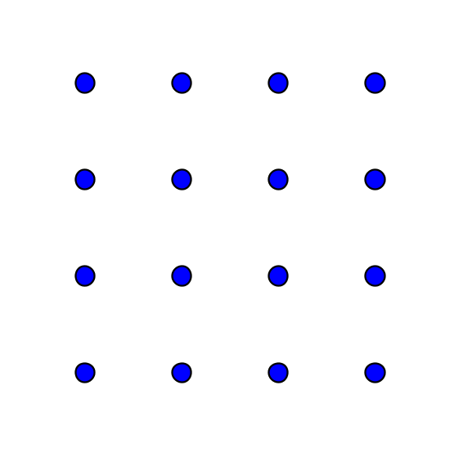

Answers:

I have got 4 solutions. There may be others.

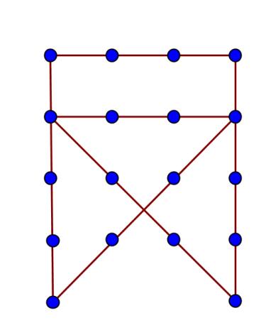
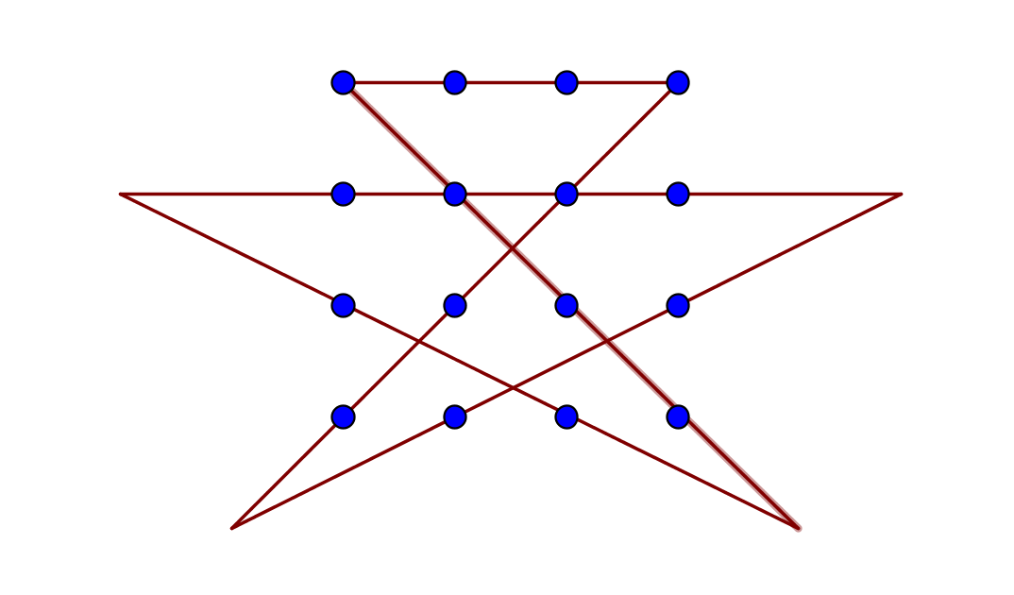

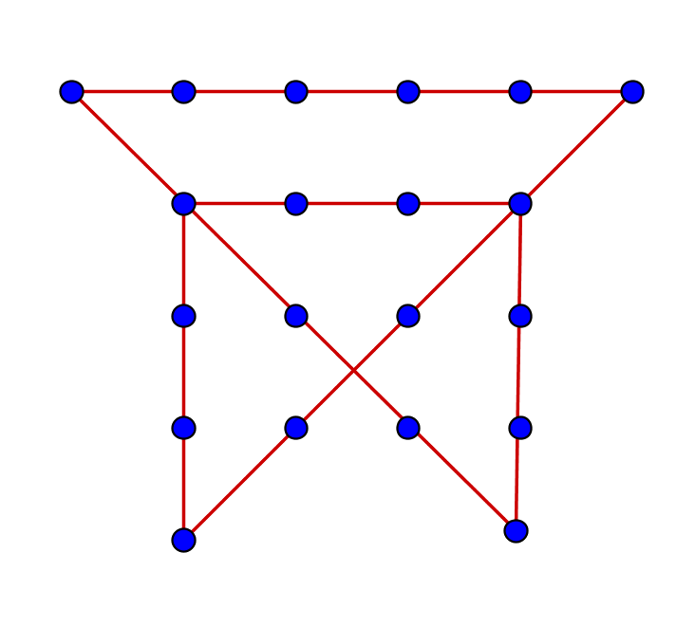

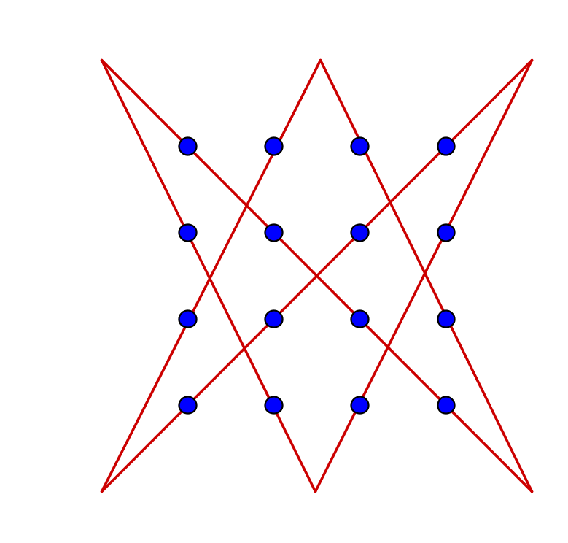
Yue Kwok Choy
12/2/2016

